“Smart Plant Pot” – Week 3

On the third week of the module, I completed a couple of CAD designs how the “Smart Plant Pot” would look like. Below are my design ideas:

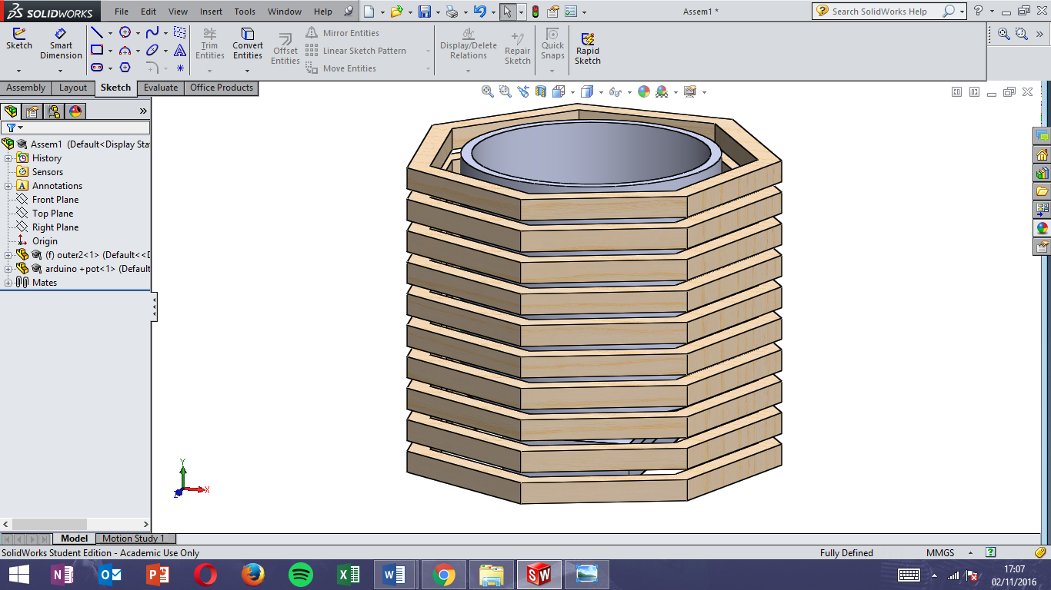

Figure 1: Design One

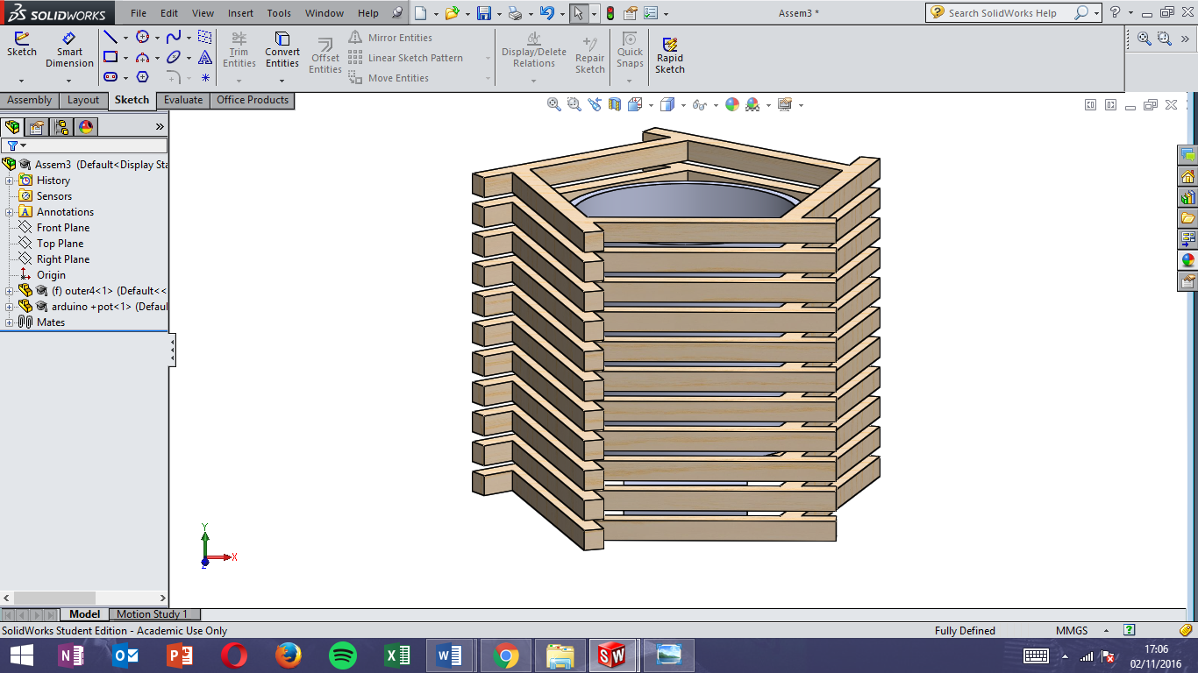

Figure 2: Design Two

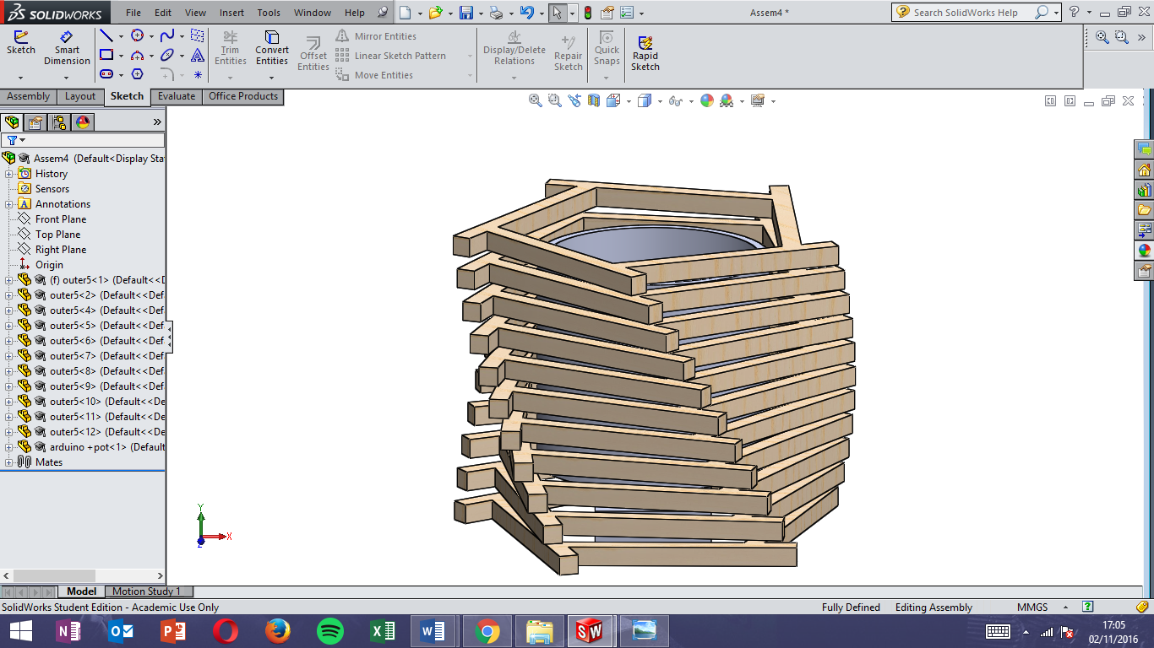

Figure 3: Design Three

As the figures shows, the product is going to be produced in wood. Wood was chosen for a couple of reasons:

* Faster manufacturing (compare to 3D printing)
* Cheaper than 3D printing
* Aesthetically better and keeps a “natural” feel to the product

The design also share similar design features, like having “slits” in between stacked cross sections. Instead of having a hole, where the LED is exposed directly to display the light, the slits allow the light to be emitted naturally.

Design One and Two was not chosen because their design is quite basic and does not evoke any feelings. Design Three on the other hand was chosen, as its spiral design is fluid but remains simple.

Nearing the end of Week 3, I also started the production of the prototype. Using the materials from the workshop, I managed to experiment with my ideas physically and see how it would look like in practice.

